**einxaPURBANCHAL UNIVERSITY**



**DEPARTMENT OF COMPUTER ENGINEERING**

**KHWOPA ENGINEERING COLLEGE  
LIBALI-2, BHAKTAPUR**

**A PROJECT REPORT**

**ON**

**ONLINE HOSPITAL SERVICES (OHS)**

Project report submitted in partial fulfilment of requirements for the award of the degree of Bachelor of Engineering in Computer Engineering(fifth semester)

**SUBMITTED BY**

Ajay Shrestha (710301)

Anish Karmi (710303)

SajanBasnet (710336)

Sudan Krishna Shrestha (710345)

**UNDER THE GUIDANCE OF**

**Er.ShivaParsadMahato**

16June2017

**TABLE OF CONTENTS**

|  |  |  |  |
| --- | --- | --- | --- |
| **Chapter** | **Title** | **Page** | |
|  |  | |
|  | Title Page | |
|  | Certificate | |
|  | Acknowledgements | |
|  | Abstract | |
|  | Table of Contents | |
|  | List of Figures | |
|  |  | |  |
| 1 | INTRODUCTION 1-2  1.1 Background  1.2Statement Of Problems  1.3 Objectives  1.4 Application  1.5 Scope & Limitation | | 1  1  2  2  2  2 |
|  |  | |  |
| 2 | LITERATURE REVIEW  2.1 Existing system  2.2 Proposed System | | 3  3  3 |
| 3 | METHODOLOGY 1-2  3.1 Generic Model  3.2USE CASE Diagram  3.3ER Diagram  3.4 Context Diagram  3.5Data Flow Diagram (DFD)  3.6Tools and Platforms | | 4  4  5  6  7  8  9 |
| 4 | RESULT AND DISCUSSION | | 10 |
| 5 | CONCLUSION AND RECOMMENDATIONS 1-2  5.1 Conclusion  5.2 Future Enhancement | | 11  11  11 |
|  | REFERENCES  APPENDIX A  APPENDIX B | | 12  13  15 |

**List of Figure**

|  |  |
| --- | --- |
| Fig 3.1.1 Generic Model | 4 |
| Fig 3.2.1 Use Case Diagram | 5 |
| Fig 3.3.1 ER Diagram | 6 |
| Fig 3.4.1 Context diagram | 7 |
| Fig 3.5.1 DFD | 8 |
| Fig A.1 Homepage | 13 |
| Fig A.2 Registration page | 13 |
| Fig A.3 Verification code send in Gmail | 14 |
| Fig A.4 Login page | 14 |
| Fig A.5 Confirmed verification | 14 |
| Fig B.1 Doctor Search and Booking appointment | 15 |
| Fig B.2 Available booking time | 15 |
| Fig B.3 Appointment booked | 16 |
| Fig B.4 News articles | 16 |
| Fig B.5 Asking question to doctor | 17 |
| Fig B.6 Answer replied by doctor for asked question | 17 |
| Fig B.7: Doctor can report inappropriate question | 17 |

**LIST OF ABBREVIATION**

OHS Online Hospital Service

DFD Data Flow Diagram

ERD Entity Relationship Diagram

OPD Patient Department

**DEPARTMENT OF COMPUTER ENGINEERING**

**KHWOPA ENGINEERING COLLEGE  
LIBALI-2, BHAKTAPUR**

**CERTIFICATE**

This is to certify that the project entitled "**ONLINE HOSPITAL SERVICES (OHS)**" submitted by Ajay Shrestha, Anish Karmi, SajanBasnet,Sudan Krishna Shresthain a partial fulfilment of the requirements for the award of the Degree of Bachelor of Engineering in Computer Engineering of Purbanchal University , is a bona fide work to the best of our knowledge and may be placed before the examination Board for their consideration.

**Panel of Examiners:**

|  |  |  |
| --- | --- | --- |
| **Name** | **Signature** | **Date** |
|  |  |  |
|  |  |  |
| **External Examiner** |  |  |
|  |  |  |
| …………………… |  |  |
|  |  |  |
| **Project Supervisor** |  |  |
|  |  |  |
| Er. Shiva Prasad Mahato |  |  |
| **Head of Department**  Er. ReenaManandhar |  |  |
|  |  |  |
|  |  |  |

**ACKNOWLEDGEMENT**

We would like to acknowledge all the individuals who provided theirguidance and assistance for the preparation of our web application “**ONLINE HOSPITAL SERVICES (OHS)**”.

We are extremely grateful to Department of computer Engineering, Khwopa Engineering College for providing us the opportunity to work on the project named “**ONLINE HOSPITAL SERVICES (OHS)**”.

We are sincerely thankful to**Er**.**Shiva Prasad Mahato**for his wonderful guidance and support to complete this project work.

Lastly, yet importantly, we would like to extend thanks to our beloved friends for providing their valuable suggestions, indispensable comments and help for completing this project work.

**ABSTRACT**

Our project entitled “**Online Hospital Services**” is a web based application which aims to provide the basic services of the hospital in an effective and efficient way by removing the traditional method of using such services. Here, the services are provided for both patient and doctor of the particular hospital and includes online registration of patients, detailed information about patients and doctors, details about treatment history of patients, searching for doctors and booking appointments online etc. The traditional method applied to use such services were done manually which leads to inconsistency in data entry, room for errors, time consuming, lack of sharing of information etc. So our web application will aim to solve such problems in hospitals. The users can use the available services in **Online Hospital Services** by logging in with their validated username and password after the registration process. It is accessible by an administrator, patients and doctors. This system consists of chunk of data which can be retrieved easily by the authorized users only which leads to better security and performance of data and its processing.

# CHAPTER 1

# INTRODUCTION

## 1.1 Background

The project Online Hospital Services (OHS) is a web application which can be used to utilize the basic services of the hospitals in an efficient and effective way. This web application includes the services which are often done manually in many hospitals like registration of patients, queries and solutions, appointments booking with doctors, keeping records of doctors and patients etc. Manual process takes more effort and physical space to keep track of paper documents, to find information and to keep details secure. When mistakes are made or changes or corrections are needed, often a manual transaction must be completely redone rather than just updated. So, in order to reduce such problems of manual system we are developing and designing this web application that establishes an orderly and systematic method of managing some operations of hospital and patient and doctors records more effectively and efficiently.

**Online Hospital Services** does not manage all operations that a hospital undergoes but provides the basic services that the users can utilize from anywhere or anyplace. Some of the basic services that OHS provides are mentioned below:

* **Online Registration**

Manual registration of patient in a hospital is a tedious process. In OHS the registration of patients can be done online in an efficient and effective manner. Patients can register themselves easily from anywhere or anyplace with the help of OHS. Verification code is sent through email which insures security of user.

* **Online Records**

With the help of this web application it is possible for the hospitals to keep the track of detailed information of their patients including their treatment history in a secured and efficient way. The hospitals also can keep the records of their doctors. An authorized user can retrieve such records and can update it if necessary. Now doctors can see their patient’s treatment history and information by using this web application rather than going through chunks of papers and files which can be time consuming.

* **Appointments booking**

With the help of OHS patients can now book themselves for an appointment with the doctors of the hospitals easily from anywhere or anyplace.

* **Video gallery**

In OHS patients will be provided with the video guidance about the different procedure a patients need to undergo in hospitals such as if a patient need to do a MRI in a hospital but is completely unknown about the MRI procedure that patients need to follow then he/she can use this video guide service and search for MRI procedure. This will help both the patients and staff of hospitals.

* **Ask a question**

With the help of this web application users can now ask and submits their queries related to their health problems or issues and they will get professional medical advice and answers

OHS can be accessed either by an administrator, patients or doctors of the hospital by logging in with their validated user id and password after the registration process.

## 1.2Statements of Problems

Some statements of problems are addressed as follows:

* **Lack of immediate retrievals:-**

The information is very difficult to retrieve and to find particular information like- E.g. - To find out about the patient’s history, the user has to go through various registers. This results in in convenience and wastage of time.

* **Lack of immediate information storage: -**

The information generated by various transactions takes time and efforts to be stored at right place.

* **Lack of prompt updating: -**

Various changes to information like patient details, doctor details, appointments details etc.are difficult to maintain make as paper work is involved.

* **Preparation of accurate and prompt reports: -**

This becomes a difficult task as information is difficult to collect from various register.

## 1.3 Objective

* To provide online appointment with doctors.
* To keep and retrieve online health records of patients.

## 1.4 Application

The main application area of OHS is hospital and other such similar institutes which involves operations between doctors and patients.

## 1.5Scope and Limitation

**Scope:**

* To allow users to make appointment easily.
* To provide reports online.

**Limitation:**

* Online payment not available.
* Only provides basic services.

# CHAPTER 2

# LITERATURE REVIEW

## 2.1 Existing system

Many organizations have been providing online services. And in recent years hospitals are also beginning to provide online services to the people. These services includeappointment booking, check-up history of patients, gallery, department information, doctor information, online payment etc. Some of the hospitals that provide these services are civil service hospital, Nepal cancer hospital, Nepal police hospital, OM hospital, etc. These hospitals provide a 24 hour emergency contact services. These websites are user-friendly and easy to use.

## 2.2Proposed System

Online Hospital Services (OHS) provide a clean and user friendly website where both patients and doctors can use services provided by the website. It helps to control the information of patients and doctors. Appointment booking, downloading reports, video gallery and question forums are the services provided by Online Hospital Services. Patients can download and view the check-up reports. The doctors can also download the reports of the patients to check for any abnormalities. Patients can view doctor schedules and make an appointment based on that. They can also search for doctors based on speciality and their name.

# CHAPTER 3

# METHODOLOGY

## 3.1 Generic Model

View reports

View reports

Answer Questions

Login

View appointments

Doctor

Admin

Online Hospital Services

Manage appointments

Manage reports

Manage news and video

Add doctors

Login

Cancel appointments

Make appointment

Ask questions

Login / Register

Patient

Fig 3.1.1 Generic Model for Online Hospital Services

## 

## 3.2USE CASE Diagram

Doctor

­

Admin

# 

Patient

Fig 3.2.1 Use Case Diagram of OHS

## 

## 3.3 ER Diagram

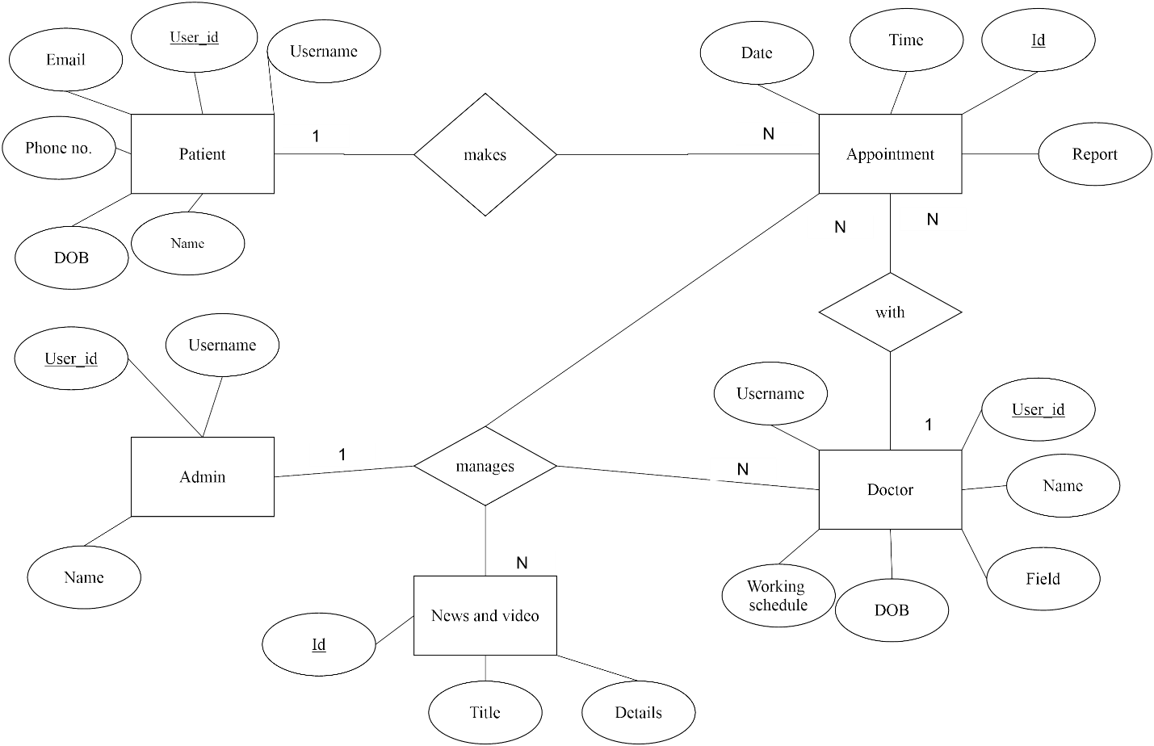

Fig 3.3.1 Entity Relationship Diagram of OHS

**3.4 Context Diagram**

## 

## 

Fig 3.4.1 Context Diagram of OHS

3.5Data Flow Diagram (DFD)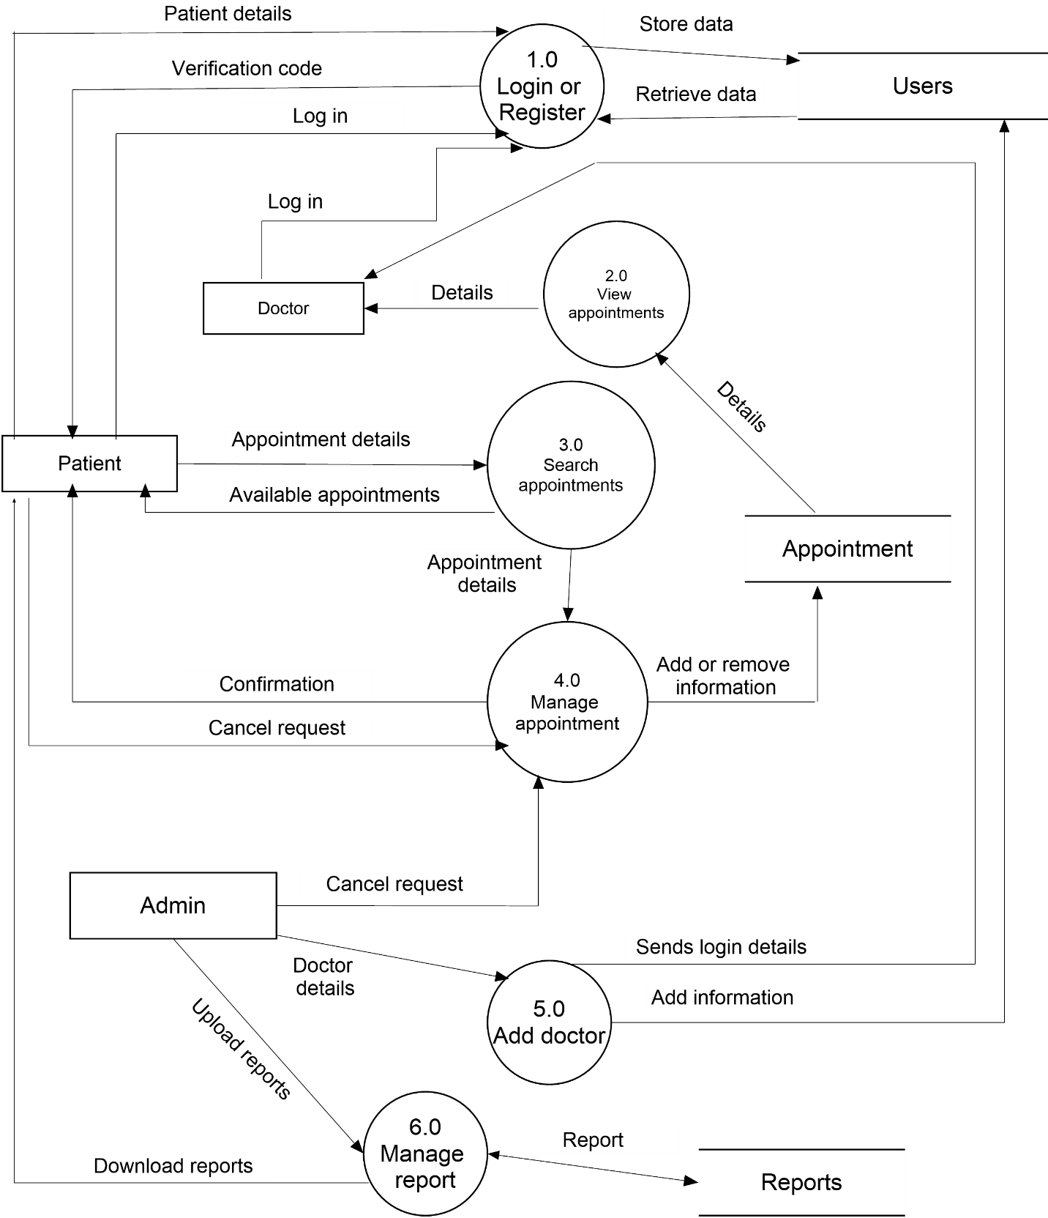

Fig 3.5.1 Data flow Diagram of OHS

## 3.6Tools and Platforms

Following tools and platforms were used for developing this web application

**Software**

* Text Editor: Sublime text,Adobe Dreamweaver 2017
* Version control system:GitHub
* Graphic software: AdobeIllustrator, Adobe Photoshop.
* Microsoft word
* XAMPP
* Front end: Html,CSS,JavaScript,J-query, Bootstrap 3.0,Font Awesome
* Server side script :PHP
* Database : MySQL

**Platform**

* Windows 7/8/10

# CHAPTER 4

# RESULT AND DISCUSSION

With the help from our web application named as Online Hospital Services (OHS), all its users will be able to experience a simple and friendly user interface in order to accomplish different task. Different task can be making an appointment with doctors in order to check up their health problems, looking at the history of the health reports/records, asking doctors questions about different health problems without even visiting the hospitals, watching and reading different health related videos and news and others.

Online Hospital Services removes traditional method of doing things in hospitals like manual records of patients, standing in queue for making an appointment with related doctors, visiting hospitals for asking simple health related queries and many more. This web application can somehow reduce both the efforts and time of both the patients and as well as of the doctors also. When a patient and doctor visit, doctor’s can now retrieve the detailed information of his/her patients, all the up-to-date health reports of the patients in just one click by using this web application. Online Hospital Services can remove the burden of both patients and doctors. Patients will not need to roam each and every time to the hospital for making appointments with doctors. Sometimes there also may be the condition when the doctor is not available when the patient has visited the hospital for appointment with that particular doctor. This will lead to the waste of money, time and effort of the patient so OHS can save the time, money and the effort of the patients.

OHS is a web application so in order to use it obviously there must me internet available. With the rapid growth of technology and need of internet many people are now dependent on the different services which are provided online. So, OHS is also one of the many web applications which facilitate for people to use the services of one of the largest organization i.e. hospital. OHS doesn’t handle all the day to day task of the hospitals such as billing, management of rooms and beds, management of staffs, management of inpatients and so on.OHS is mainly designed and developed for the out patients of the hospitals who only needs some basic services of hospitals like making appoint for doctor for a health check up.

# CHAPTER 5

# CONCLUSION AND RECOMMENDATION

With the rapid evolution of information technology, people are becoming even more and more electronically connected. As a result providing service has become more challenging. Our web application provides the basic services of one of the large organization i.e. hospitals using which people can save their time and effort. Here we have provided services like online doctor’s appointment, update/cancel appointment, downloading patient’s report, viewing doctor’s information, hospital OPD services, registering of patients and doctors, ask questions about health related to related doctor’s and get answers, some video gallery where they can learn about first aid etc. Since we are entering details of the patients electronically in the data will be secured. Using this application we can retrieve patient’s history with a single click. Thus processing information will be faster. It guarantees accurate maintenance of Patient details. It easily reduces the book keeping task and thus reduces the human effort and increases accuracy, speed and reliability.

Online Hospital Services will provide a user friendly interface to its user which is very simple and effortless to use. The health records, details and other vital information’s of each and every patient will be secured from any possible threats and can be retrieved easily by the authorized users only. This web application is designed such that it responds to a user's screen size and orientation and also is supported by any browsers.

**Future Enhancements**

* Better user interface.
* Better responsive design.
* Security enhancements.
* More services will be included.

# REFERENCE

**Website**

1. Using JQuery Framework ,https://www.codecademy.com/learn/jquery,<https://www.w3schools.com/jquery/>[28 April 2017]
2. PHP tutorial,<http://php.net> , <https://www.w3schools.com/php>,<https://www.tutorialspoint.com/php>[29 April 2017]
3. Get started with Font Awesome,<http://fontawesome.io/get-started>[01 March 2017]
4. MySQL manual , <https://www.mysql.com> ,<https://dev.mysql.com/doc/refman/5.7/en/database-use.html>, [1 March 2017]
5. Grandy Hospital, <http://grandehospital.com>[1 June 2017]

# APPENDIX A

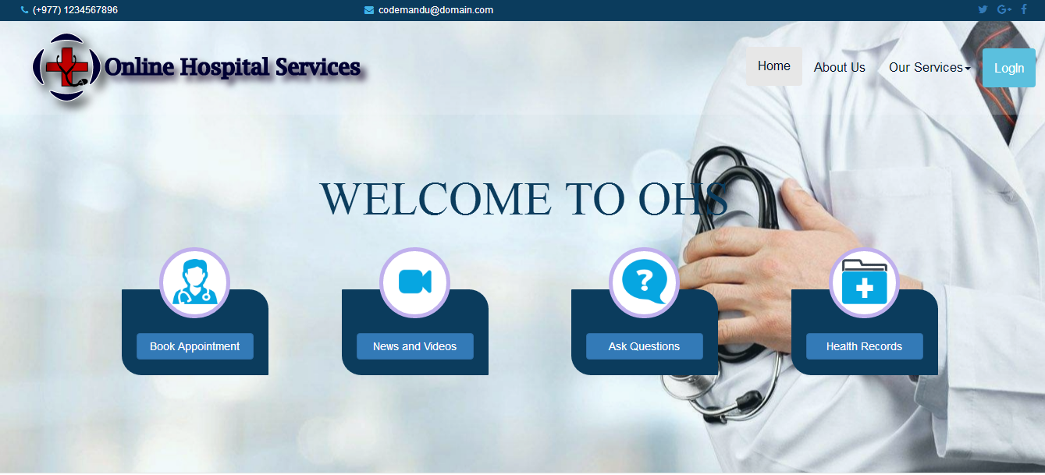

Fig A.1: Homepage

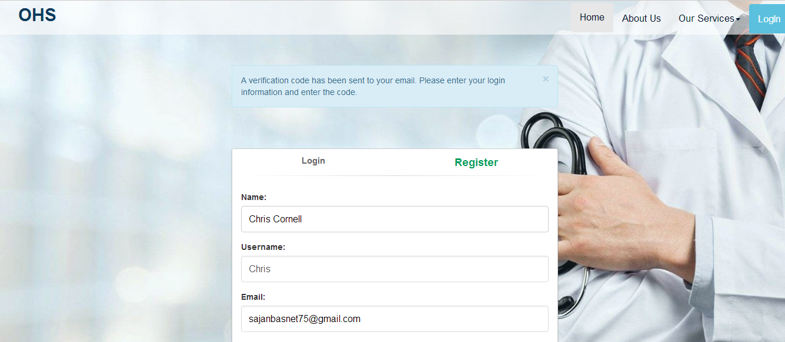

Fig A.2: Registration page

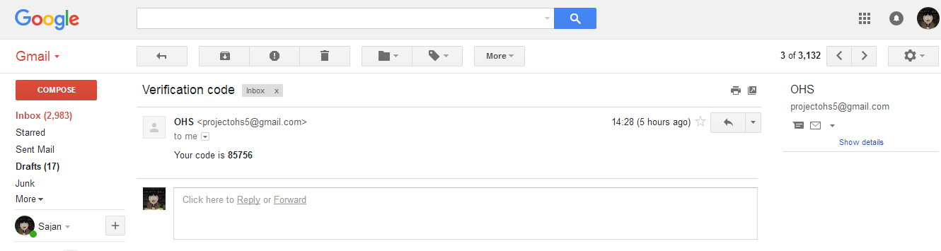

Fig A.3: Verification code send in Gmail

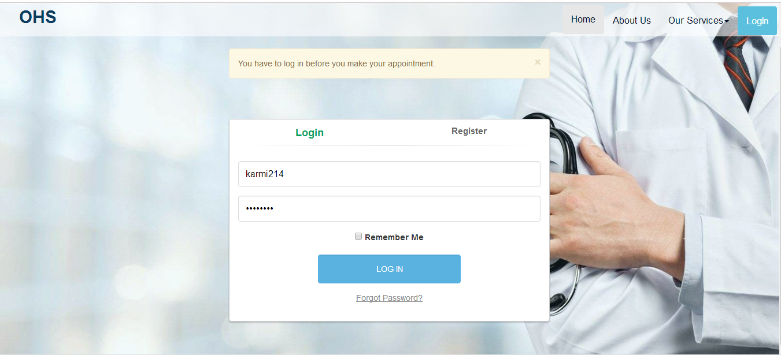

Fig A.4: Login page

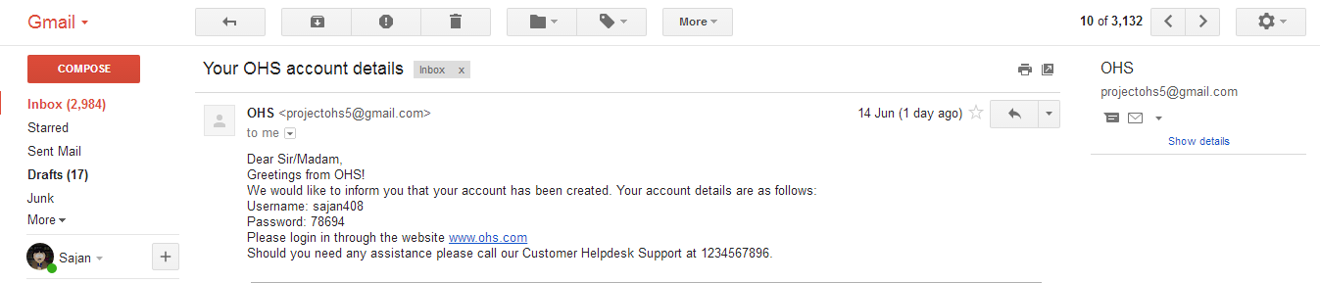

Fig A.5: Confirmed verification

# APPENDIX B

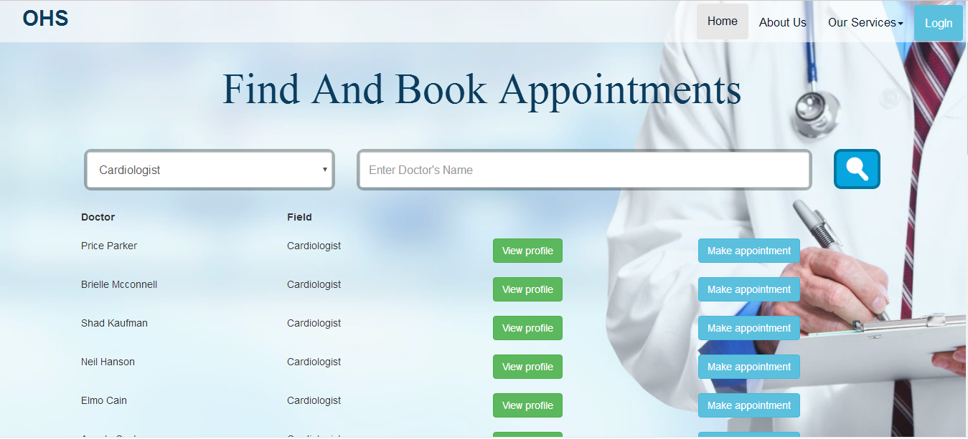

Fig B.1: Doctor Search and Booking appointment

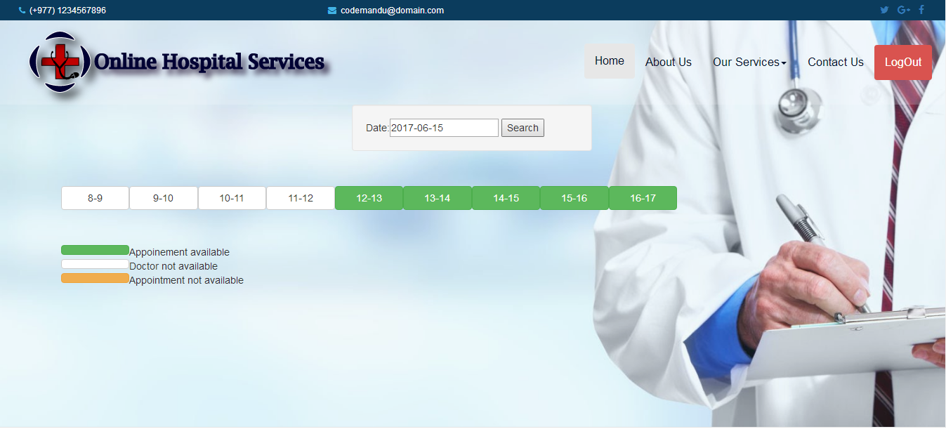

Fig B.2: Available booking time

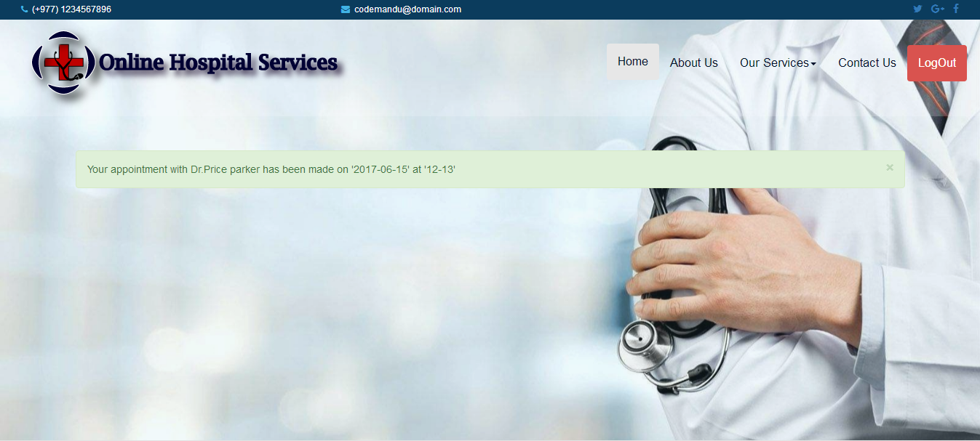

Fig B.3: Appointment booked

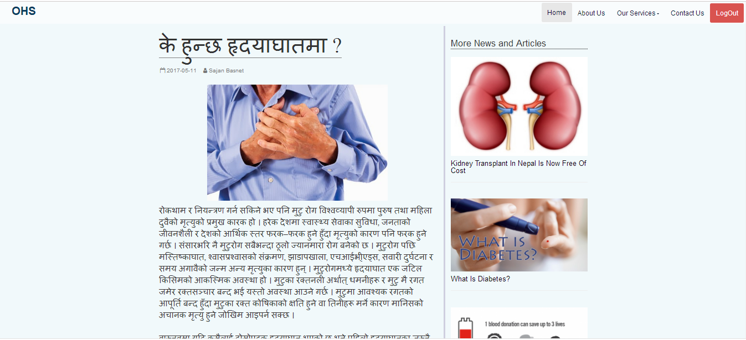

Fig B.4: News articles

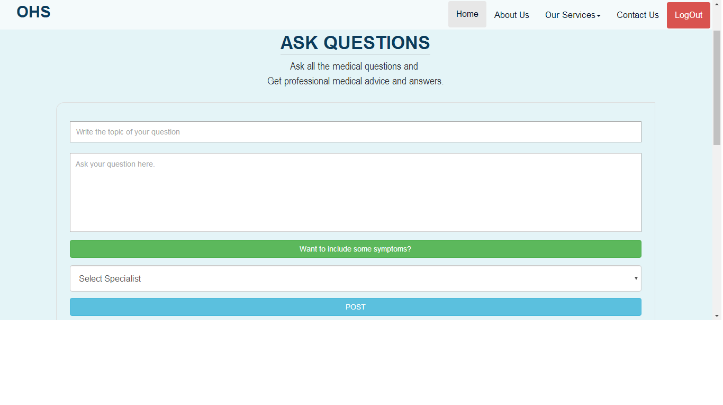

Fig B.5: Asking question to doctor

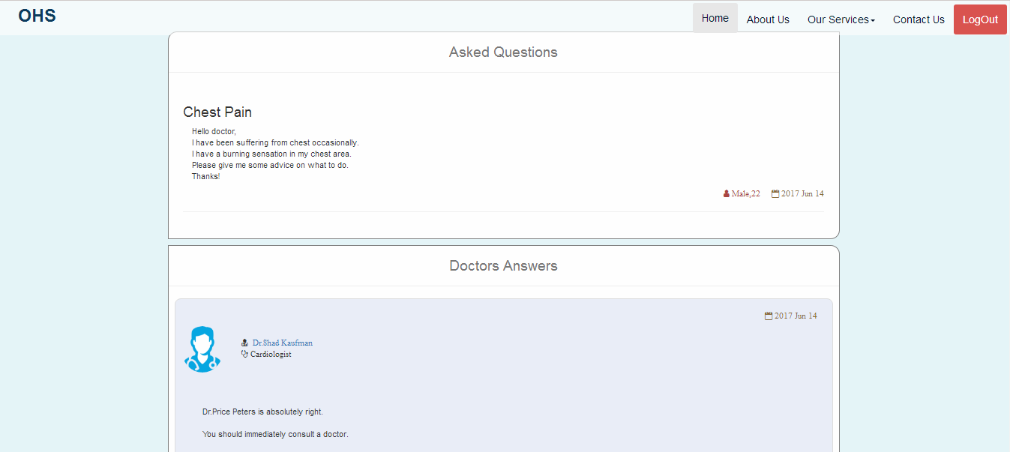

Fig B.6: Answer replied by doctor for question asked

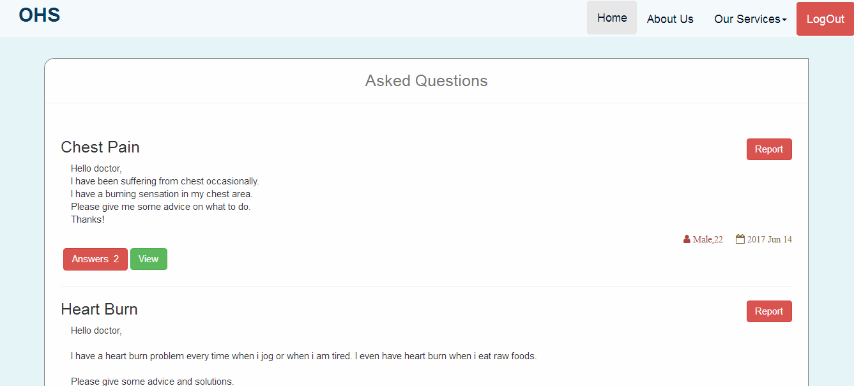

Fig B.7: Doctor can report inappropriate question